Project 1: Static Foundations
Feedback for the CSI Video Game Development Club site
Student: Chris Sanchez Course: CSC 436, Fall 2026 Reviewed at: 078dd1c
Repo: github.com/Chris-VSanchez/CSC-436_Projects Live: chrisvsanchez.netlify.app

Your grade is posted in Brightspace. This document is the reasoning behind it, category by category.

How this review was made
Your instructor reviewed this project with Claude (Anthropic's AI) as a second set of eyes. Claude cloned the repo, read both pages, the 522-line stylesheet and the script, ran the W3C validator on both pages, loaded the live site in real viewports at 320, 375, 768 and 1280 pixels, opened and closed the contact info on all four leader cards and measured whether any of it was clipped, checked both outbound links, compared the live site to the repo, and read every commit that touches Project 1/, including what the folder held on the September 15 deadline. Every note in this document was read and approved by your instructor.

The short version
This is a real website for a real club, and it looks like one. The purple-to-blue hero, the gold marquee, the dark panels and the Sen typeface form one consistent identity across both pages. The leader cards are the best piece of work on the site: they are generated by JavaScript from a data array, and one click listener on the grid handles all four buttons through event delegation, which is a pattern most of the class has not reached yet. Both outbound links work. The marquee stops for visitors who ask for reduced motion. Nothing scrolls sideways at 320, 375, 768 or 1280, because the two grids use auto-fit with minmax and reflow on their own. The README has all four required items, and the commit messages say exactly what each change did.
The gaps are mostly in the HTML. Neither page has a main. Each page has two h1s. The nav links are bare anchors instead of a list, and "Games" goes to #. The brand puts a p inside a span, which is each page's validator error, and the About page jumps from h1 to h3. The four leader images are injected with no alt at all, and the html tag has no lang. There are no real images on the site, only one decorative SVG reused four times. In the CSS, the palette is typed by hand, the About paragraphs use br for line breaks, which reads raggedly on a phone, and the buttons have no focus style.
One more thing, said plainly. On the September 15 deadline, Project 1/ held a 71-line page with a header, a hero and the marquee. The leader grid, the footer, the About page, all of the JavaScript and the Netlify deploy arrived between September 21 and October 3. Your instructor is handling the timing; this review grades the finished site.

What Claude measured
Check | Result
W3C HTML validator | index.html: 1 error (p inside span) plus lang and untitled-section notes. about.html: same error plus h1 to h3 skip
Horizontal scroll at 320 / 375 / 768 / 1280 px | None, on both pages
Semantic elements per page | header, nav (bare anchors), 3 section, footer. No main, no article
h1 per page | 2 on both pages
Layout | 8 Flexbox containers, 2 Grids, both auto-fit with minmax(min(240px, 100%), 1fr)
Leader grid at 375 / 1280 | 1 / 4 columns. Event grid: 1 / 2 / 3
Media queries | 1, prefers-reduced-motion. Layout is intrinsic
Custom properties / focus styles | 0 / nav links only
Leader cards | 4 from a data array; toggle verified open and close on all four, independently
Contact info clipping | None: content ends 6 px inside the 250 px card at 1280 and at 375
Images | 4 img, all background.svg (3062 by 1500, 341 KB), injected without alt
Outbound links | Discord 200, CSI Connect 200; Games is href="#"
Console errors | 0
Commits touching Project 1/ | 11, Sep 14 to Oct 3, all descriptive
Project 1/ at the Sep 15 deadline | index.html 71 lines, style.css 178 lines; no script, About page, footer or deploy
README | Title, description, how to run, live URL: all four
Live vs repo | Identical apart from Netlify pretty URLs

The site, phone and desktop
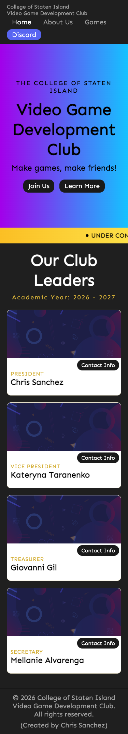  Home, 375 by 667, full page. Nav wraps under the brand; leader cards stack. | 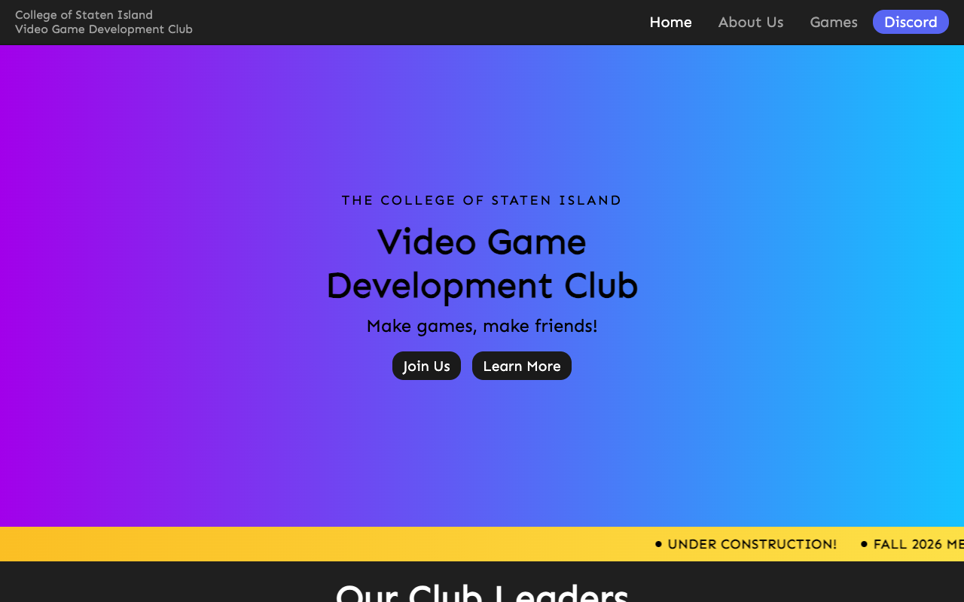  Home, 1280 by 800. Full-height gradient hero and the gold marquee.
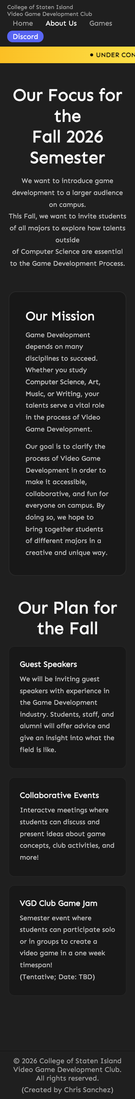  About, 375 by 667, full page. The br line breaks land mid-sentence. | 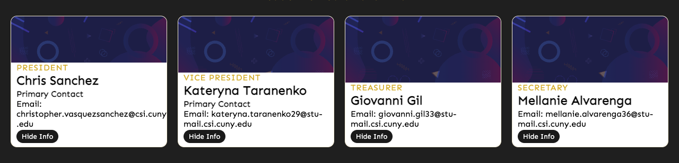  Leader cards at 1280 with all four contact blocks open. Nothing is clipped.

Semantic HTML

What is working
- A header with a brand link and a nav, sections for the hero, the marquee and the leaders, and a footer on both pages (index.html lines 28 to 108). Every page has a real title. The active page is marked with aria-current="page" and the CSS styles it (style.css lines 67 to 70), which is the correct way to show "you are here" and almost nobody in the class did it.

What to change
- No main on either page. The sections sit directly in body. Wrap everything between the header and the footer in main. It is the landmark screen-reader users jump to, and the brief lists it.
- Two h1s per page. "Video Game Development Club" and "Our Club Leaders" on the home page (lines 55 and 92); "Our Focus for the Fall 2026 Semester" and "Our Plan for the Fall" on About (lines 79 and 111). Keep one h1 per page and make the others h2. On About, the event cards then become h3 under an h2, which also clears the heading-skip error.
- The nav is bare anchors, and one goes nowhere (lines 39 to 46). Put the four links in a ul with li items. "Games" is href="#": either build the page or drop the link until it exists.
- The brand's p inside a span (lines 33 to 35) is each page's validator error. A span cannot hold a paragraph. Remove the span, or make it a div.
- The leader images have no alt (script.js line 47), and the html tag has no lang. The SVG is decorative, so alt="" is the right value, but it has to be there. Add lang="en" to both pages.
- Small: the leader cards and event cards are divs. Each is a self-contained item, which is what article is for.

CSS layout

What is working
- Intrinsic layout done well. Both grids use repeat(auto-fit, minmax(min(240px, 100%), 1fr)) (style.css lines 243 to 254 and 472 to 478). The min(240px, 100%) inside the minmax keeps a single column from overflowing a very narrow phone; most people who use auto-fit miss it. Flexbox with flex-wrap does the header, the nav and the hero buttons. The marquee is a real keyframe animation with a prefers-reduced-motion rule that stops it (lines 515 to 522). Hover lifts on the cards, a consistent radius language, one typeface throughout. The design is the most distinctive in the class.

What to change
- No custom properties. The gold #d4af37, the panel greys, the gradient stops and the Discord blue are typed by hand across 522 lines. Put them in :root and the next color change is one edit.
- Line breaks are hard-coded into the copy. The About paragraphs use br to break lines where they looked right on your screen (about.html lines 82 to 84), and there is an inline margin style on line 94. On a phone those breaks land mid-sentence. Delete the br tags, give the paragraphs max-width: 60ch with margin-inline: auto, and let the browser wrap. Related: .mission sets align-items and gap but has no display: flex or grid, so both declarations do nothing (style.css lines 447 to 460).
- Focus styles stop at the nav. The nav links get :focus (line 67); the hero buttons, the Contact Info buttons and Hide Info do not. Add one :focus-visible rule for everything interactive.
- Small: the font is loaded with @import inside the stylesheet (line 2), which delays it until the CSS has downloaded. A link in the head starts it sooner.

Responsive design

What is working
- No horizontal scroll at 320, 375, 768 or 1280 on either page, measured in real viewports. The leader grid goes from four columns to one, the event grid from three to two to one, and the nav wraps under the brand. All of it without a single breakpoint, which the brief explicitly allows.

What to change
- The intrinsic layout covers the grids but not the page. Nothing else changes between a phone and a desktop: the hero is 80 percent of the screen tall at every width, the nav wraps wherever it runs out of room, and the fixed line breaks in the About copy do not adapt at all. One min-width query that lays the header out deliberately, and the max-width fix for the paragraphs, would make the phone version look designed rather than reflowed.

JavaScript interaction

What is working
- Data-driven rendering and event delegation (script.js lines 4 to 57). The leaders live in one array of objects, a for...of loop builds a card for each, and each button carries a data-id. One listener on the grid handles every card: closest("[data-id]") finds the button, find looks the leader up by id, and insertAdjacentHTML adds the contact block with a "Primary Contact" label only when primaryContact is true (lines 60 to 107). Claude opened and closed all four; each works independently, and the label appears on exactly the two leaders flagged for it. Zero console errors.
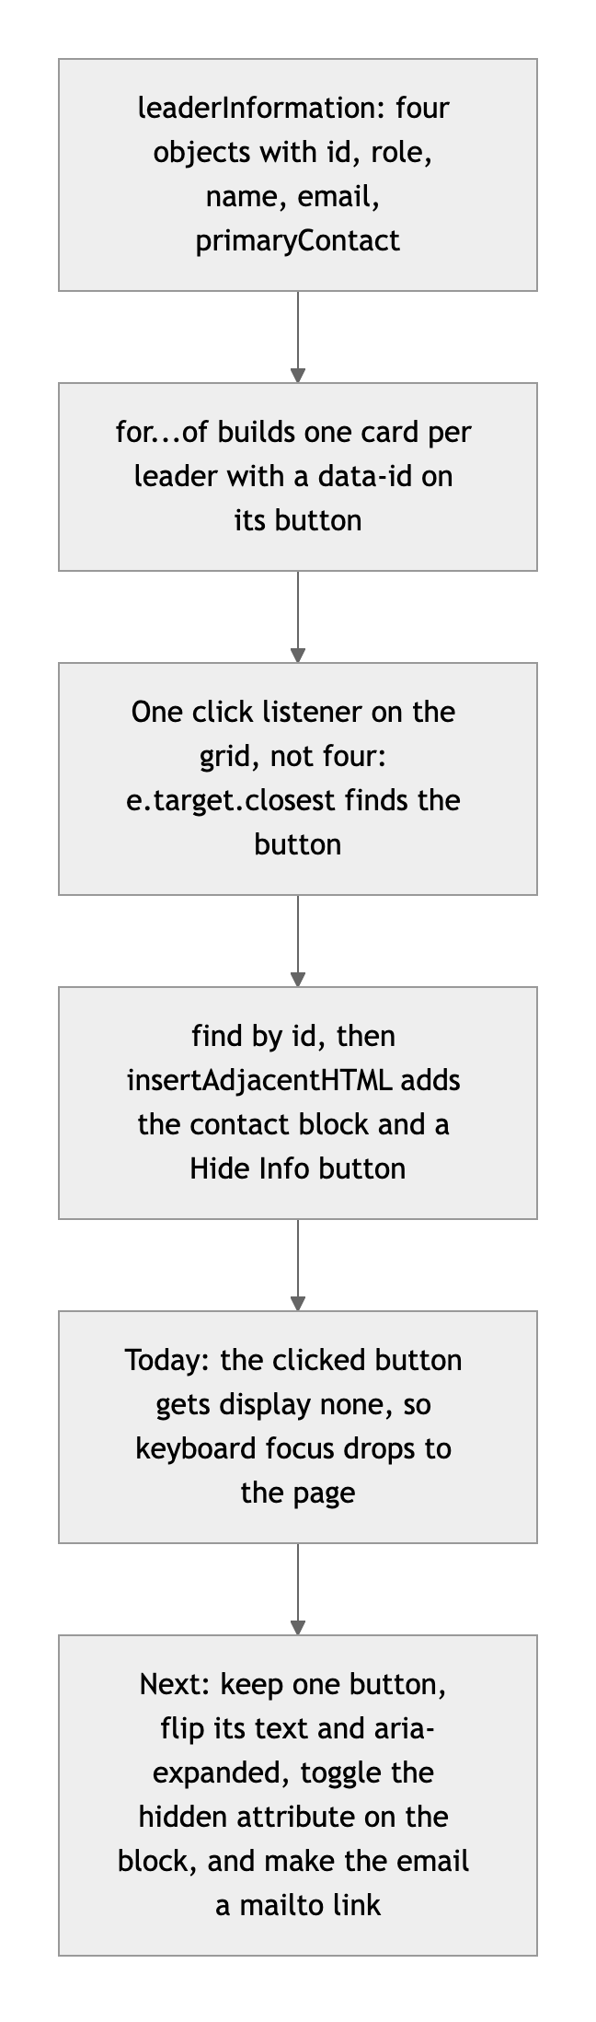
Diagram 1. How the leader cards work today, and the next step.

What to change
- The toggle loses keyboard users. Pressing Contact Info hides that button with an inline display: none (line 77), so focus falls back to the page and a keyboard user has to tab from the top to reach Hide Info. Keep one button: flip its text, set aria-expanded, and toggle the hidden attribute on a contact block that is built once. Fewer lines, and nobody gets lost.
- The email is plain text. Wrap it in a mailto link so a visitor can click it.
- Small: the four email addresses belong to other students. Make sure each officer is happy to have a school address on a public site and in a public repo; a club contact address, or the CSI Connect page, is the usual alternative.

Repository and deployment

What is working
- The README is complete: title, a real description, step-by-step run instructions, and the live link. One repo with a folder per project is a clean way to hold the semester, and the README says so. The site is on Netlify as the brief asks, it is public, and it matches the repo apart from Netlify's tidy /about URLs. Eleven commits touch Project 1/, and each message says what changed and why. That is exactly the kind of history the brief describes.

What to change
- The timing. On September 15 the folder held the header, the hero and the marquee. The leader grid, footer, About page, script and deploy came between September 21 and October 3. Your instructor is handling that separately. For Project 2, the habit to build is shipping a working core by the deadline and polishing afterward.
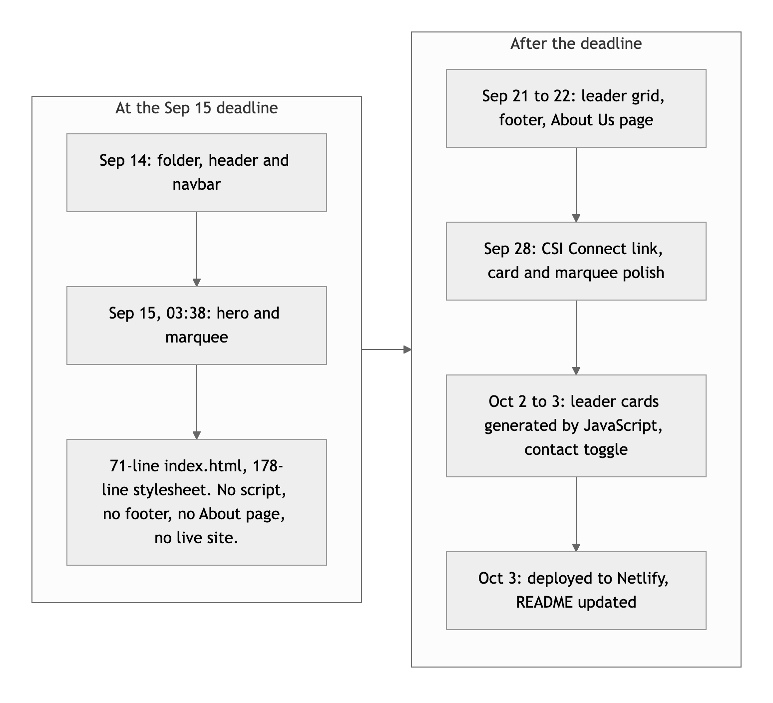
Diagram 2. What existed at the deadline, and what came after.
- Small: there is no .gitignore at the repo root. Project 2 has its own, but a root one with .DS_Store and .vscode/ protects every folder. "Dvelopment" in the README is a typo.

Content and polish

What is working
- The content is specific and real: the club's mission, why it wants students outside Computer Science, three concrete plans for the fall, the 2026 to 2027 officers, a working Discord invite and a working CSI Connect sign-up. The copy is clear and has a point of view. The footer credits you.

What to change
- There are no real images. The only image is one decorative SVG, 341 KB, reused behind all four leader cards. The brief asks for real images with alt text. Officer photos (with their permission), a photo from a meeting, or a screenshot of a game a member made would change the page more than any other single edit.
- "UNDER CONSTRUCTION!" and a dead "Games" link make a finished site read as unfinished. Replace the marquee's first message with something current, and remove "Games" until the page exists.

Your next moves
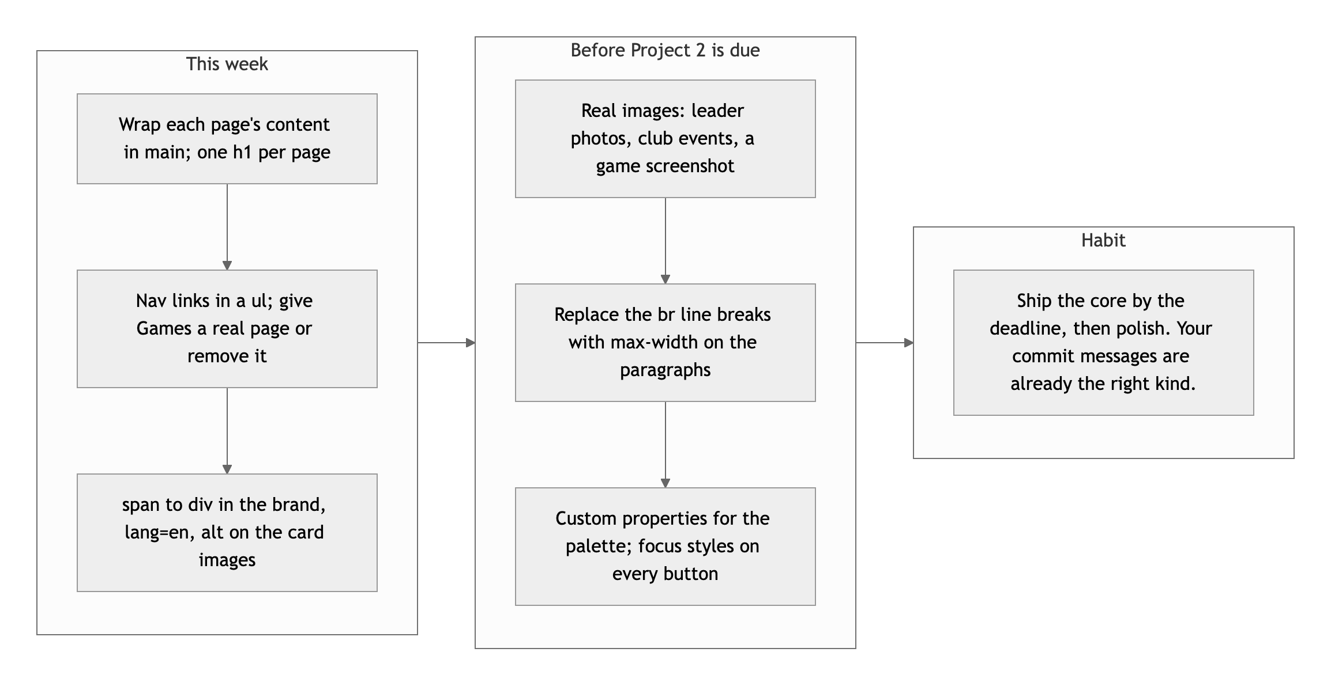
Diagram 3. This week, before Project 2 is due, and the habit.
- Fix the outline. main, one h1, a list nav, lang, alt, and the span. Twenty minutes, and both pages validate.
- Add real images and let the text wrap. Photos with alt text, and no more br in paragraphs.
- Finish the toggle. One button with aria-expanded, and a mailto link.

This is a site the club can actually use, Chris; the next step is making the HTML underneath as solid as the design on top.
This review lives in a pull request on your repo and only adds files under Project 1/feedback/. Your grade is in Brightspace. Questions go to office hours or the Brightspace board.

